**LAPORAN PRAKTIKUM JARINGAN KOMPUTER**

**MODUL 6**

**“SPANNING TREE PROTOCOL”**



**Oleh:**

**NAMA : Daffa Putra Alwansyah**

**NIM : L200190031**

**KELAS : A**

**PRODI : INFORMATIKA**

**Fakultas Komunikasi dan Informatika Universitas Muhammadiyah Surakarta**

**C. Kegiatan Praktikum  
  
1. Kegiatan 1. Topologi 1  
  
Tugas 1A**  
Membuat “Topologi” seperti di modul dan memberi nama SW1,SW2, dan SW3.

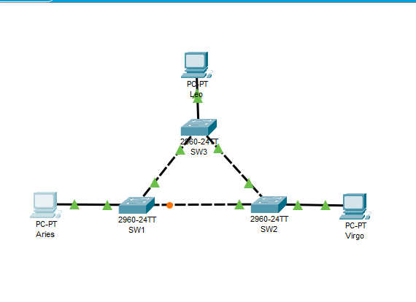

**Tugas2A**  
Konfigurasi alamat IP pada masing-masing PC, serta mengganti nama PC menjadi Leo, Aries dan Virgo.

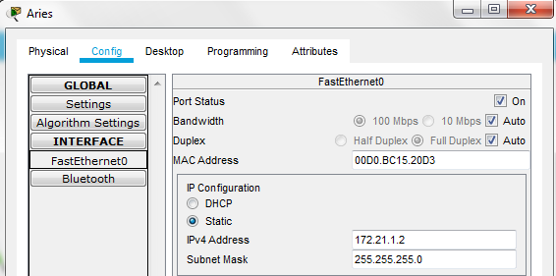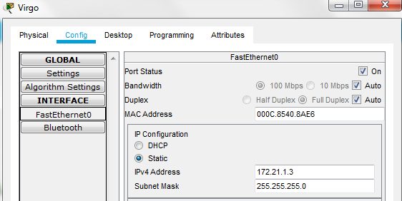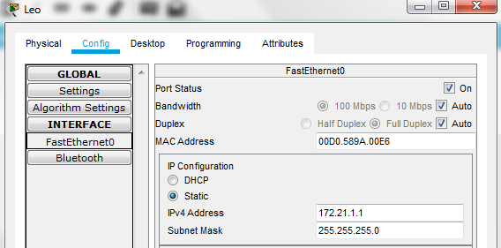

**Tugas 4A**  
Melihat status STP pada masing-masing Switch, dengan masuk ke “*CLI*” > masuk ke mode privileged > ketik “*show spanning-tree*” pada SW1,SW2, dan SW3.  
-SW1

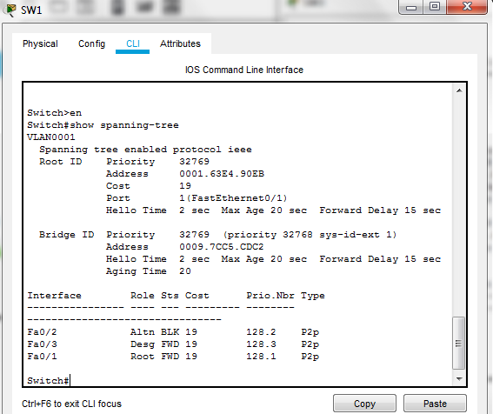

-SW2

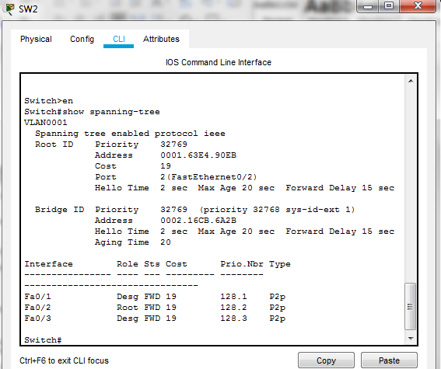

-SW3

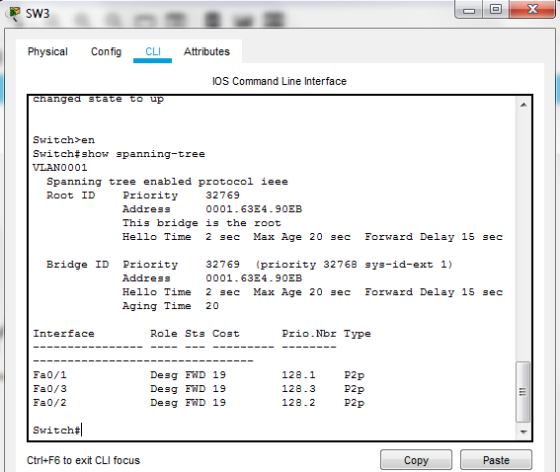

**Tugas 4B**Mengisi tabel pada tiap switch:  
-SW1

|  |  |  |
| --- | --- | --- |
| **No** | **Variabel** | **Nilai** |
| 1 | Root ID | 32769 : 0001.63E4.90EB |
| 2 | Priority | 32769 |
| 3 | MAC Adress | 0009.7CC5.CDC2 |
| 4 | Bridge ID | 32769 : 0009.7CC5.CDC2 |
| 5 | Cost(0/1;0/2;0/3) | 19/19/19 |
| 6 | Hello Time | 2 sec |
| 7 | Max Age | 20 sec |
| 8 | Forward Delay | 15 sec |

-SW2

|  |  |  |
| --- | --- | --- |
| **No** | **Variabel** | **Nilai** |
| 1 | Root ID | 32769 : 0001.63E4.90EB |
| 2 | Priority | 32769 |
| 3 | MAC Adress | 0002.16CB.6A2B |
| 4 | Bridge ID | 32769 : 0002.16CB.6A2B |
| 5 | Cost(0/1;0/2;0/3) | 19/19/19 |
| 6 | Hello Time | 2 sec |
| 7 | Max Age | 20 sec |
| 8 | Forward Delay | 15 sec |

-SW3

|  |  |  |
| --- | --- | --- |
| **No** | **Variabel** | **Nilai** |
| 1 | Root ID | 32769 : 0001.63E4.90EB |
| 2 | Priority | 32769 |
| 3 | MAC Adress | 0001.63E4.90EB |
| 4 | Bridge ID | 32769 : 0001.63E4.90EB |
| 5 | Cost(0/1;0/2;0/3) | 19/19/19 |
| 6 | Hello Time | 2 sec |
| 7 | Max Age | 20 sec |
| 8 | Forward Delay | 15 sec |

**Tugas 4C:**

- Root bridge : SW3 (dapat dilihat “*this bridge is the root*”).  
- Designated bride : SW2 (dapat dilihat dari role “*Desg,Root,Desg*”).  
- Root port : SW1(Fa0/1) dan SW2(Fa0/2).  
- Designated port : SW1(Fa0/3), SW2(Fa0/1;Fa0/3) dan SW3(Fa0/1;Fa0/2;Fa0/3).  
**Tugas 4D:**

- Keadaan forwading : SW1(Fa0/1;Fa0/3), SW2(Fa0/1;Fa0/2;Fa0/3).

dan SW3(Fa0/1;Fa0/2;Fa0/3) (dapat dilihat dari status “*FWD*”).

- Keadaan blocking : SW1(Fa0/2) -> (dapat dilihat dari status “*BLK*”).

**Tugas 5A:**

**Ping PC Leo ke PC Virgo**

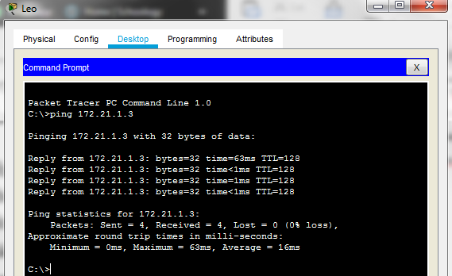

Masuk ke PC > Desktop > Command Prompt, lalu ketik “ping 172.21.1.3”.

**Tugas 6A**

Lakukan perintah pada setiap Switch:  
Untuk menyimpan konfigurasi jaringan

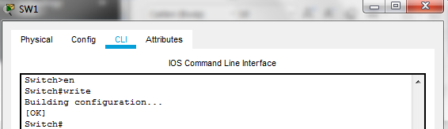

1. **Kegiatan 2. Topologi 2**

Membuat “Topologi” sama seperti di modul.

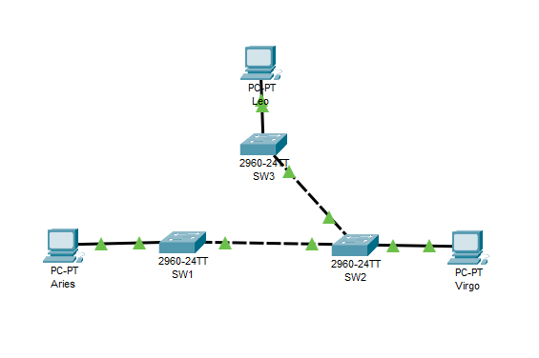

**Tugas 9A**Melihat status STP pada masing-masing Switch, dengan masuk ke “CLI” > masuk ke mode privileged > ketik show spanning-tree pada SW1,SW2, dan SW3.  
  
-SW1

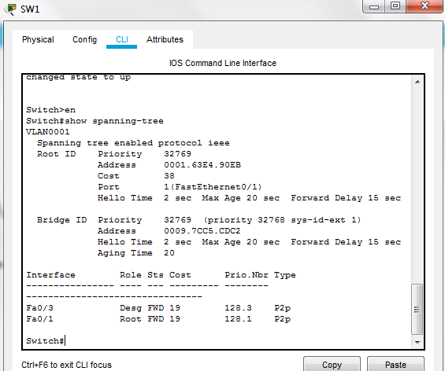

-SW2

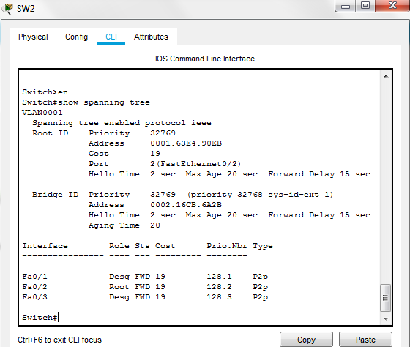  
  
-SW3

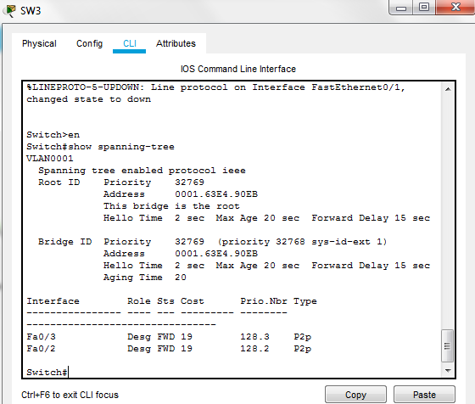

Mengisi tabel pada masing-masing switch:  
-SW1

|  |  |  |
| --- | --- | --- |
| **No** | **Variabel** | **Nilai** |
| 1 | Root ID | 32769 : 0001.63E4.90EB |
| 2 | Priority | 32769 |
| 3 | MAC Adress | 0009.7CC5.CDC2 |
| 4 | Bridge ID | 32769 : 0009.7CC5.CDC2 |
| 5 | Cost(0/1;0/3) | 19/19 |
| 6 | Hello Time | 2 sec |
| 7 | Max Age | 20 sec |
| 8 | Forward Delay | 15 sec |

-SW2

|  |  |  |
| --- | --- | --- |
| **No** | **Variabel** | **Nilai** |
| 1 | Root ID | 32769 : 0001.63E4.90EB |
| 2 | Priority | 32769 |
| 3 | MAC Adress | 0002.16CB.6A2B |
| 4 | Bridge ID | 32769 : 0002.16CB.6A2B |
| 5 | Cost(0/1;0/2;0/3) | 19/19/19 |
| 6 | Hello Time | 2 sec |
| 7 | Max Age | 20 sec |
| 8 | Forward Delay | 15 sec |

-SW3

|  |  |  |
| --- | --- | --- |
| **No** | **Variabel** | **Nilai** |
| 1 | Root ID | 32769 : 0001.63E4.90EB |
| 2 | Priority | 32769 |
| 3 | MAC Adress | 0001.63E4.90EB |
| 4 | Bridge ID | 32769 : 0001.63E4.90EB |
| 5 | Cost(0/2;0/3) | 19/19 |
| 6 | Hello Time | 2 sec |
| 7 | Max Age | 20 sec |
| 8 | Forward Delay | 15 sec |

- Root bridge : SW3 (dapat dilihat “*this bridge is the root*”).  
- Designated bride : SW2 (dapat dilihat dari role “*Desg,Root.Desg*”).  
- Root port : SW1(Fa0/1) dan SW2(Fa0/2).  
- Designated port : SW1(Fa0/3), SW2(Fa0/1;Fa0/3) dan SW3(Fa0/2;Fa0/3).

- Keadaan forwading : SW1(Fa0/1;Fa0/3), SW2(Fa0/1;Fa0/2;Fa0/3).  
dan SW3(Fa0/2;Fa0/3) (dapat dilihat dari status “*FWD*”).

- Keadaan blocking : None (Tidak ada).

**Tugas :  
Ping PC Leo ke PC Virgo**

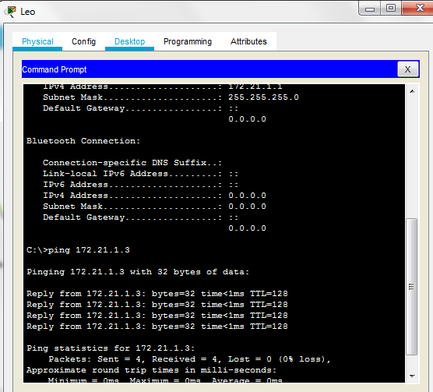

Masuk ke PC > Desktop > Command Promp, lalu ketik “ping 172.21.3”

**Tugas**  
Lakukan perintah pada setiap Switch:

Untuk menyimpan konfigurasi jaringan

